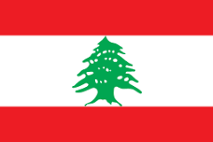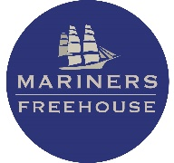

Lebanese Night – 13th April
Served from 4pm – 8.30pm

STARTERS
Baba ghanouj smoked aubergine with tahini sauce, garlic and lemon juice (gf, v, ve, df)
Samake Hara pan seared haddock with spicy sauce (gf, df)
Hummus with Kawarma humus with fine diced cooked beef with pinenuts* (gf, df)
Fatouch Salad cucumber, tomato, onion, mixed peppers, rocket and crispy pitta with suma dressing (gfo, v, ve, df)

MAINS
Chicken Shawarma shredded chicken served with salad, fries, pickles, garlic sauce (gfo, df)
Shish Taouk marinaded chicken skewers served with salad, fries and garlic sauce (gfo, df)
Lamb Kebab lamb skewers served with salad, fries, grilled tomato & pepper, tzatziki (gfo)
Stuffed Peppers peppers stuffed with rice, tomato and onions cooked on Tomato sauce (gf, v, ve, df)

DESSERT
Baklava (v)
Blossom orange rice pudding with pistachio* & pomegranate seeds (v)

3 course £29 per person

£10pp deposit when booking. Please email your menu choices to bookings@marinersfreehouse.co.uk by 9th April 2024.

*nut allergen

GF – Gluten free, V – Vegetarian, Ve – Vegan, O – Option, DF - Dairy free
Allergy & Intolerance information is available on request. Please advise us if you have any food allergies and intolerances before you order. Some dishes can be modified to gluten free or vegans. We will do our best to accommodate you. We are NOT a nut free kitchen.

